Exp 41 SELENIUM SCRIPT TO AUTOMATE DROPDOWN SELECTION

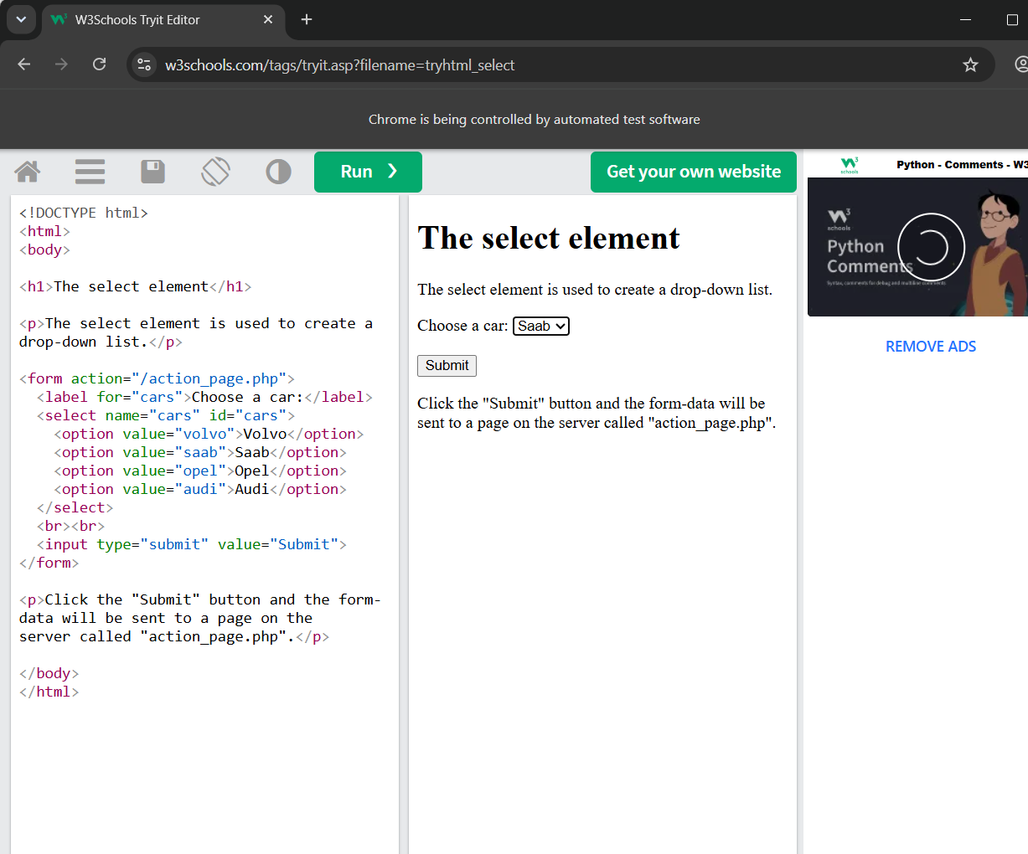

Exp 42 SELENIUM SCRIPT TO AUTOMATE CHECKBOX AND RADIO BUTTON SELECTION
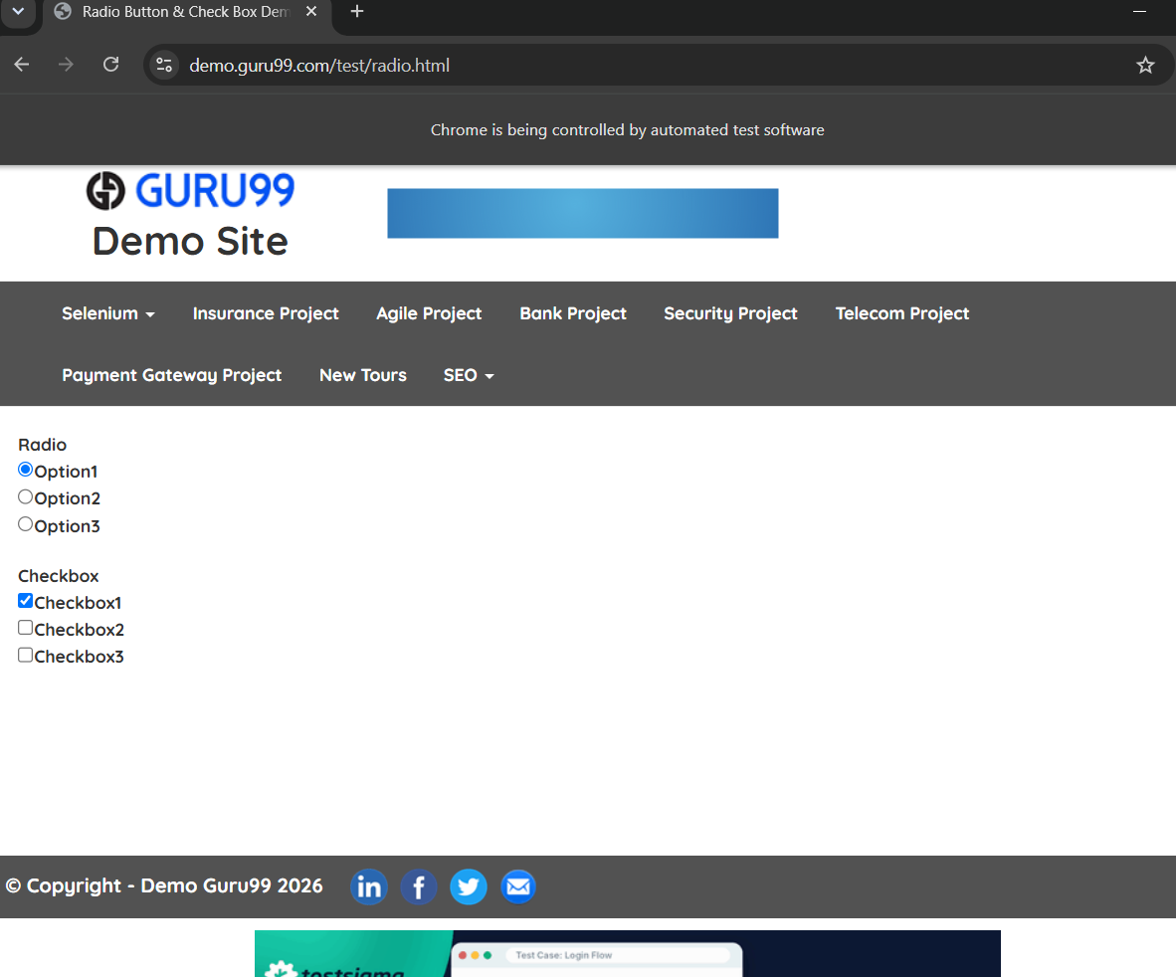
\
EXP 43 43.Write a Selenium automation script to handle JavaScript alert, confirm, and prompt pop-ups using the Chrome browser.

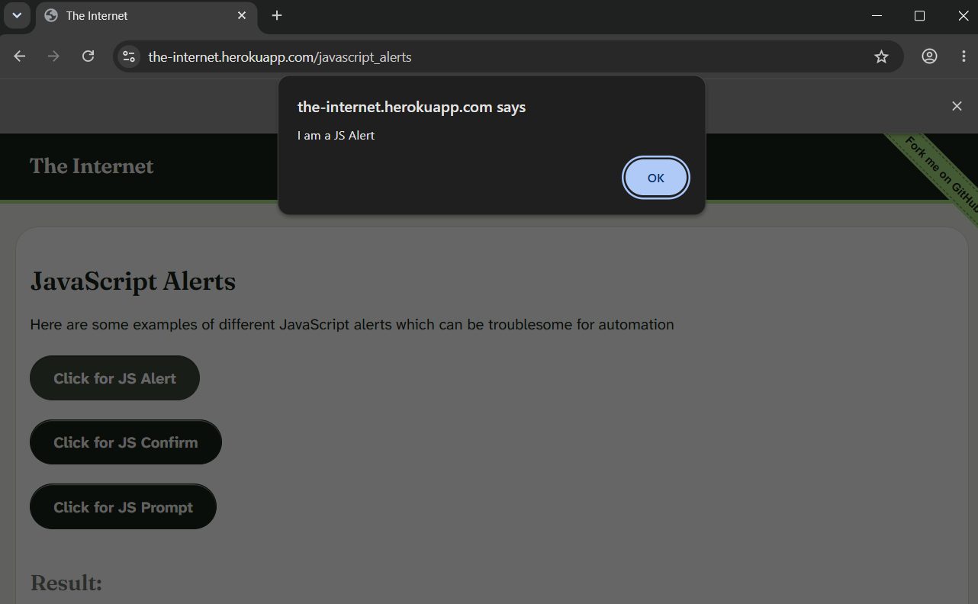

Exp 44 44.Write a Selenium program to automate file upload functionality on a web application using the Chrome browser.
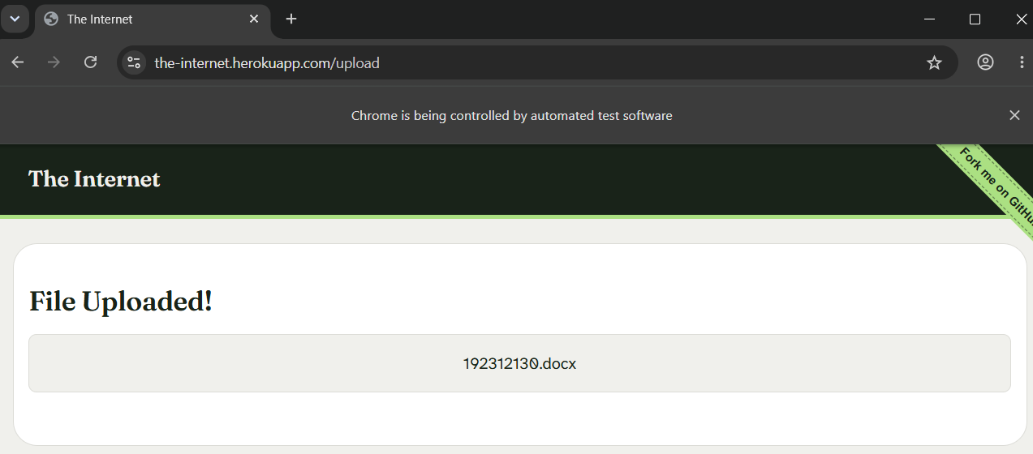

- Write a Selenium automation script to capture a screenshot of a web page and store it in the local system using the Chrome browser.



